AWS cloud-watch
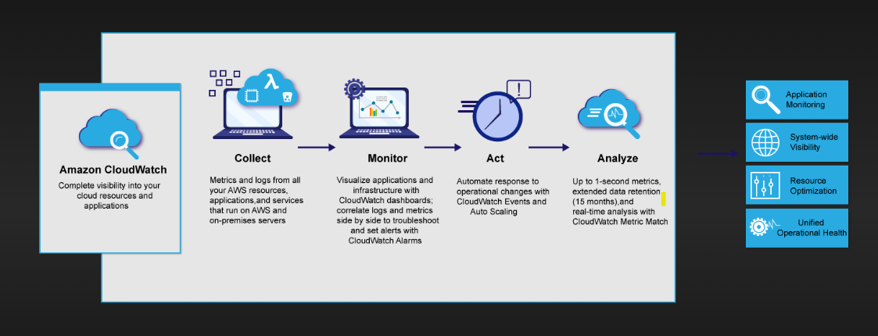
Collect, access, and analyze your resource and application data using powerful visualization tools.
Improve operational performance using alarms and automated actions set to activate at predetermined thresholds.
Seamlessly integrate with more than 70 AWS services for simplified monitoring and scalability.
Use cases:
• Monitor application performance
• Perform root cause analysis
• Optimize resources proactively
• Test website impacts

AWS Cloud-Trail:

CloudTrail is enabled on your AWS account when you create it. When activity occurs in your AWS account, that activity is recorded in a CloudTrail event. You can easily view events in the CloudTrail console by going to Event history.
Event history allows you to view, search, and download the past 90 days of activity in your AWS account. In addition, you can create a CloudTrail trail to archive, analyse, and respond to changes in your AWS resources. A trail is a configuration that enables delivery of events to an Amazon S3 bucket that you specify
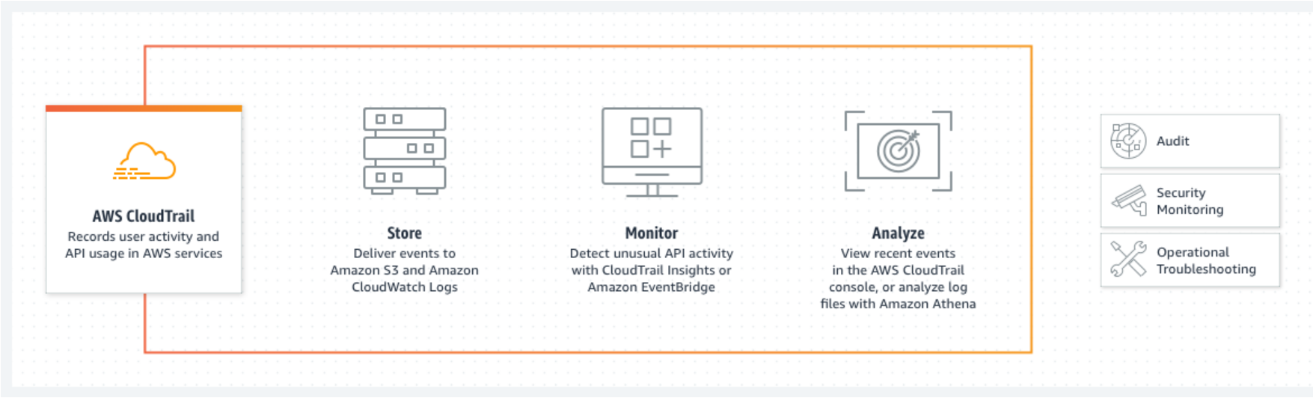
AWS SNS:
Amazon SNS stands for Simple Notification Service, which is utilized to convey the push messages from the application to the subscribing ends or other applications. It is a completely managed messaging service for both applications-to-application (A2A) and application-to-person (A2P) communication. It provides the ability to create a Topic that is a logical access point and communication channel. Each topic has a different name that identifies the SNS endpoint for publishers to post messages and subscribers to register for notifications.

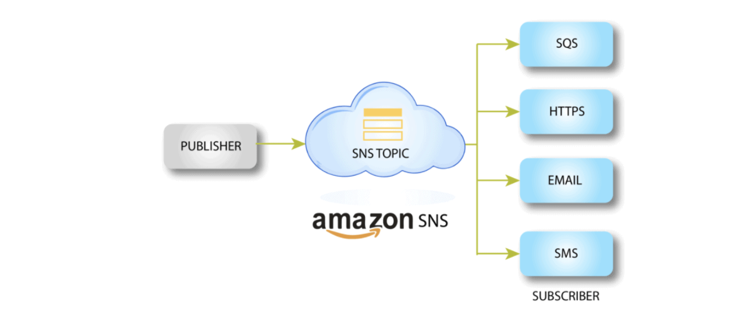

AWS SQS
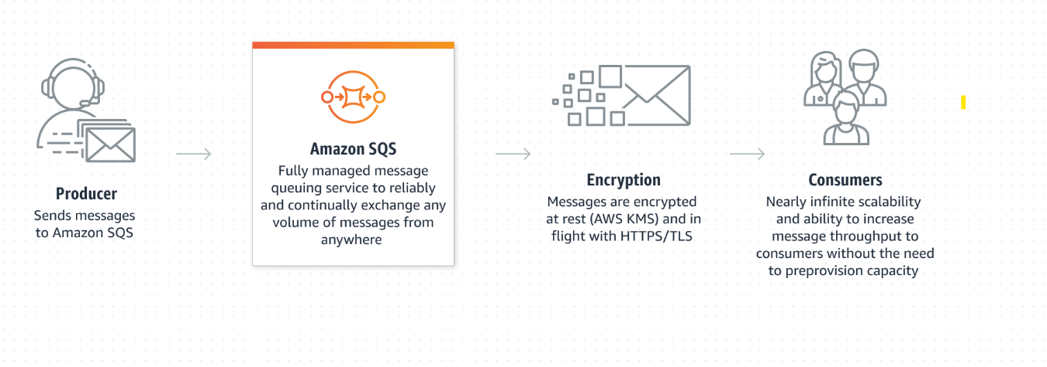
Amazon Simple Queue Service (SQS) is a fully managed message queue that helps decouple and scale distributed systems by allowing services to communicate asynchronously.
One service puts a message into a queue
Another service reads and processes it independently

Why SQS?
- Decouples services (no tight dependencies)
- Handles traffic spikes smoothly
- Prevents data loss
- Simple, reliable, and scalable

1️⃣ Amazon SNS (Simple Notification Service)

🔹 What is SNS? (Simple words)
SNS is a push-based messaging service used to send notifications to multiple subscribers instantly.
Think of SNS like a broadcast system 📢.

🔹 How SNS works
- Publisher sends a message to a Topic
- Subscribers receive the message
- Subscribers can be:
  - Email
  - SMS
  - HTTP/HTTPS
  - Lambda
  - SQS queues

🔹 Real-time Scenario
E-commerce Order Alert
- Order placed → SNS topic
- SNS sends:
  - Email to customer
  - SMS to delivery team
  - Message to SQS for order processing
👉 One message → many receivers

🔹 Common Use Cases
- Application alerts
- System notifications
- Fan-out architecture
- Triggering Lambda functions
- Billing alerts

🔹 Interview One-liner
SNS is a pub-sub, push-based service used to send notifications to multiple subscribers in real time.

2️⃣ Amazon SQS (Simple Queue Service)
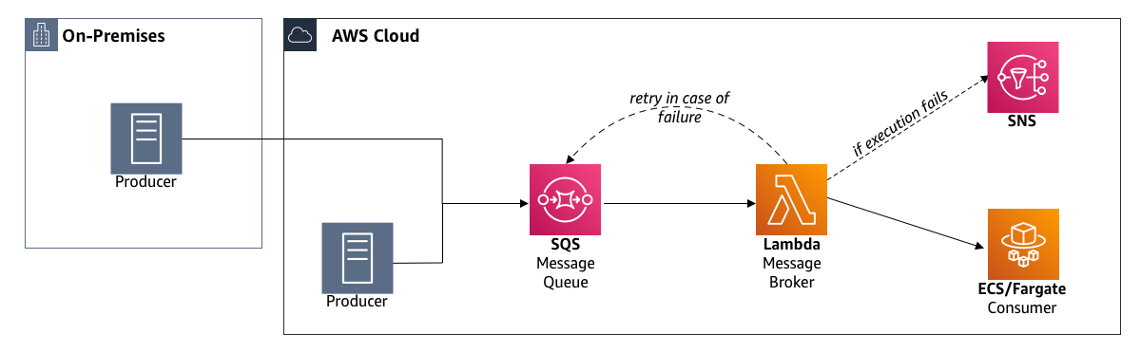

🔹 What is SQS?
SQS is a pull-based message queue used to decouple applications.
Think of SQS as a task waiting line 🧾.

🔹 How SQS works
- Producer sends messages to Queue
- Consumer polls messages
- Message is deleted after processing

🔹 Types of SQS
Type | Use
Standard | High throughput, at-least-once delivery
FIFO | Exactly-once, ordered messages

🔹 Real-time Scenario
Video Processing System
- User uploads video
- Message goes to SQS
- Worker servers pick tasks and process videos
- If worker fails → message remains
👉 No data loss

🔹 Common Use Cases
- Background jobs
- Microservices communication
- Order processing
- Buffering traffic spikes

🔹 Interview One-liner
SQS is a pull-based message queue used to decouple and scale distributed systems.

🔁 SNS vs SQS (Very Important for Interview)
Feature | SNS | SQS
Model | Push | Pull
Use | Notifications | Task processing
Delivery | To many | One consumer
Persistence | No | Yes
📌 SNS + SQS together = Fan-out pattern

3️⃣ Amazon CloudWatch
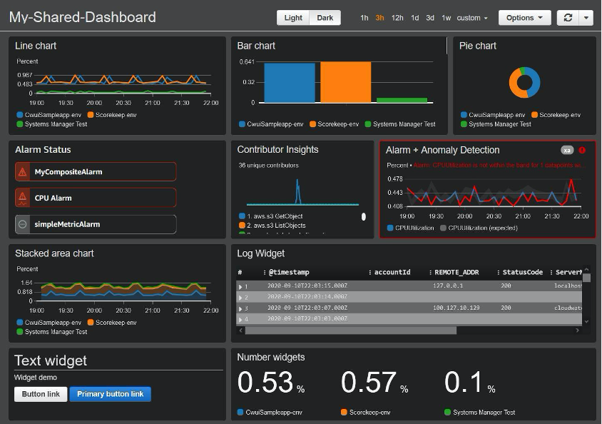
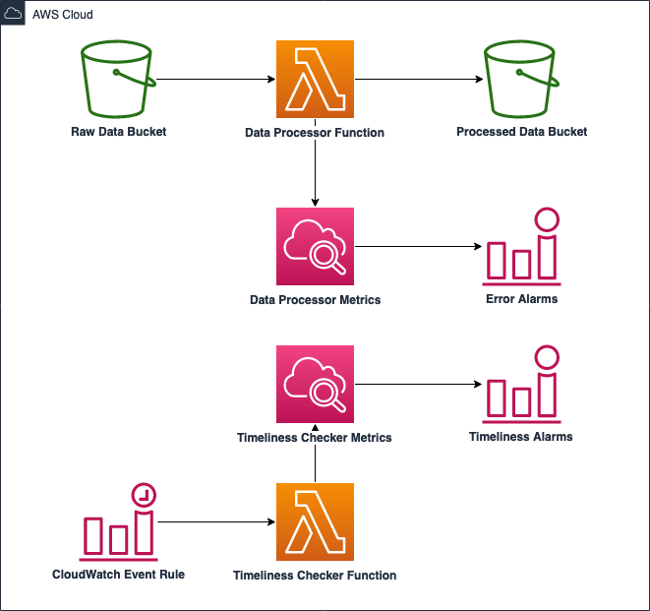
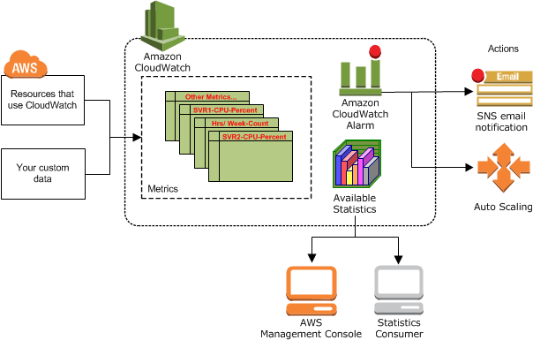
🔹 What is CloudWatch?
CloudWatch is a monitoring service for AWS resources and applications.
It answers:
- Is my system healthy?
- Is CPU high?
- Did my app crash?

🔹 What CloudWatch Monitors
- Metrics → CPU, memory, latency
- Logs → Application logs
- Alarms → Trigger actions
- Dashboards → Visual monitoring

🔹 Real-time Scenario
EC2 Auto-Scaling
- CPU > 80%
- CloudWatch alarm triggers
- Auto Scaling adds EC2 instance
- SNS notification sent

🔹 Common Use Cases
- Performance monitoring
- Log analysis
- Auto-scaling triggers
- Alerting system issues

🔹 Interview One-liner
CloudWatch is used to monitor AWS resources using metrics, logs, and alarms.

4️⃣ AWS CloudTrail
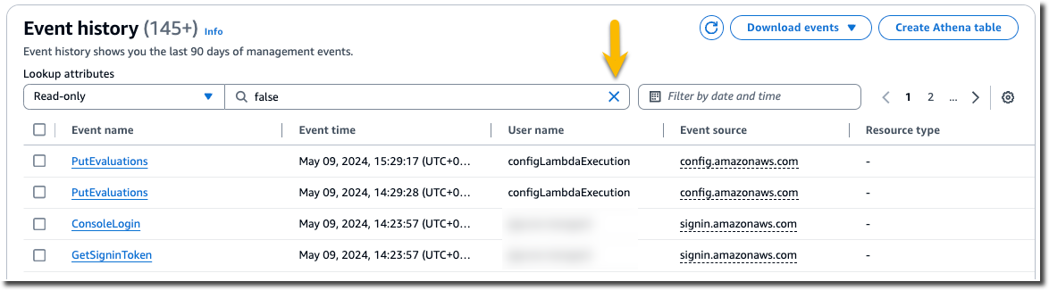
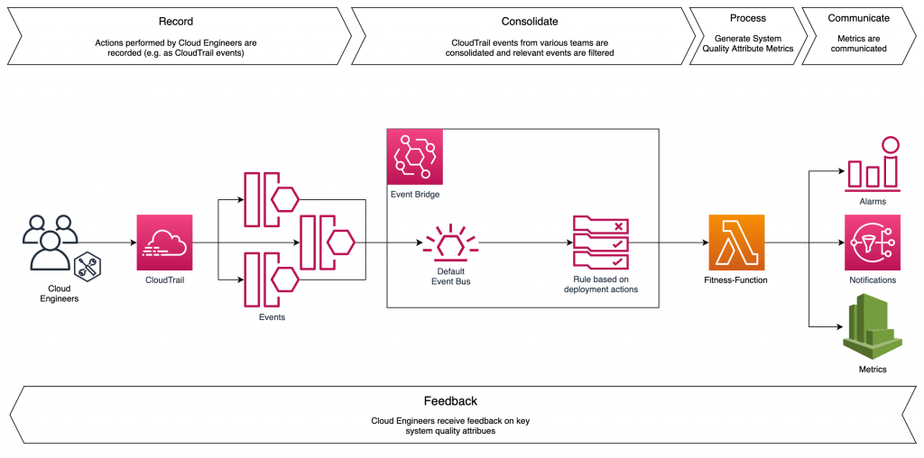
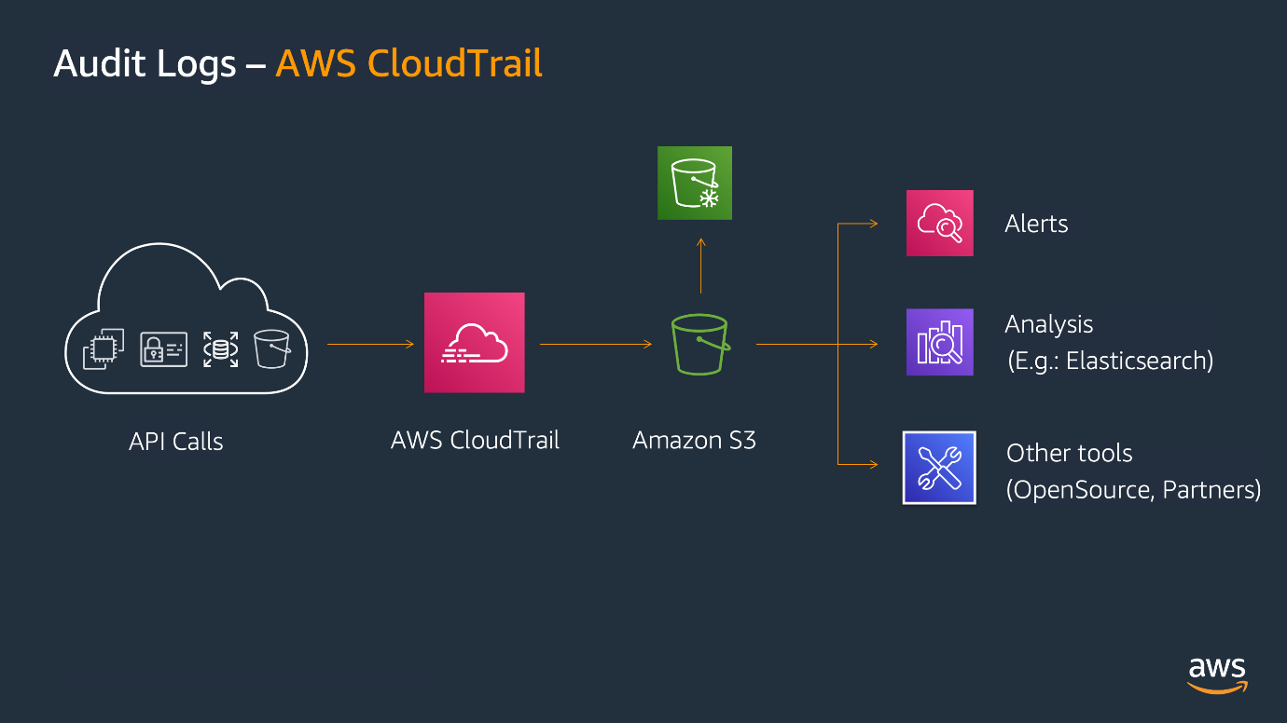
🔹 What is CloudTrail?
CloudTrail tracks API activity in your AWS account.
Think of CloudTrail as security CCTV footage 🎥.

🔹 What CloudTrail Records
- Who did what
- When it happened
- From where
- Which AWS service

🔹 Real-time Scenario
Security Investigation
- EC2 instance deleted
- CloudTrail shows:
  - IAM user
  - Time
  - IP address
- Used for auditing & compliance

🔹 Common Use Cases
- Security audits
- Compliance
- Incident investigation
- Tracking configuration changes

🔹 Interview One-liner
CloudTrail is used for auditing and tracking AWS API calls and user activity.

🔍 CloudWatch vs CloudTrail (Frequently Asked)
Feature | CloudWatch | CloudTrail
Purpose | Monitoring | Auditing
Tracks | Performance & logs | API activity
Who uses | DevOps | Security & Compliance

🎯 When to Use What (Interview Trick)
Requirement | Service
Send notifications | SNS
Process background jobs | SQS
Monitor performance | CloudWatch
Audit user actions | CloudTrail

🧠 Sample Interview Answer (Combo Question)
Q: How do SNS, SQS, CloudWatch, and CloudTrail work together?
SNS sends notifications, SQS queues messages for processing, CloudWatch monitors system health and triggers alarms, and CloudTrail audits all user and API activity for security and compliance.

